1. Let’s finish the following implementation that we left unfinished in previous lecture.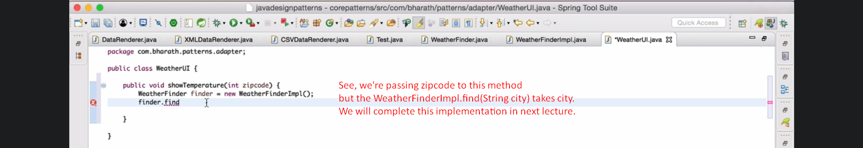
2. 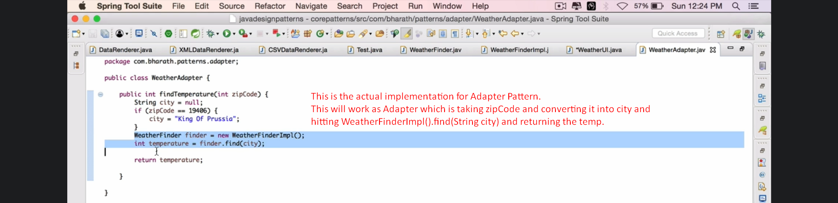
3. 